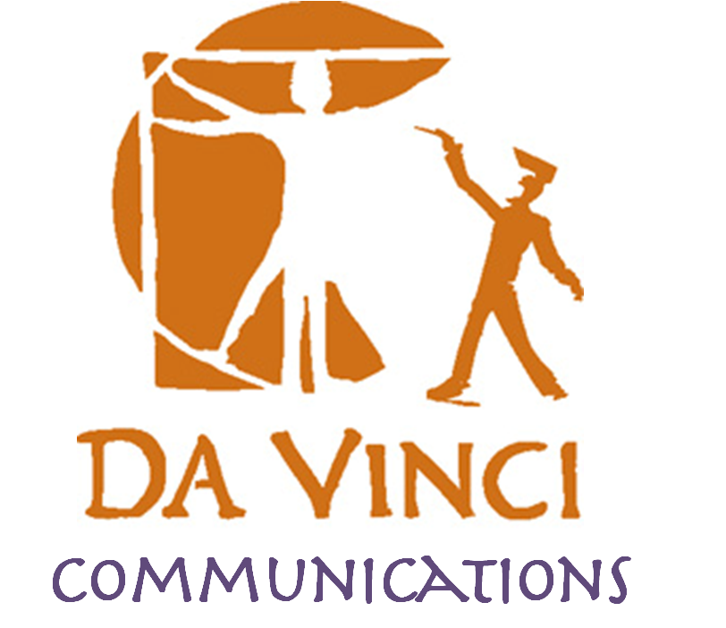
DVC Family Association Meeting Agenda

Meeting Date: Tuesday September 15th @ 6pm

Mission Statement: The Da Vinci Schools Family Association is a non-profit organization dedicated exclusively to charitable and educational purposes in support of the students, teachers, and staff.

Objective: The objective of this association is to support the Da Vinci Schools; to encourage positive communication between parents, staff, and teachers of Da Vinci; to raise parents’ awareness and promote parents’ involvement in school issues; and to raise and administer funds and accept educational equipment and in order to provide additional educational benefits beyond those provided by the school district and state of California.

Topic: | Person: | Time: | Notes:
Welcome | Nathan Barrymore | 6:00 | Sign in sheet reminder  Family Association overview
School updates | Nathan Barrymore | 6:10 | - Calendar  - Events  - Advisory  - College courses
Sports Update | Thomas Curry | 6:30
Annual Giving | Carla Levenson | 6:40
Family teams | ??? | 6:50

Contact Info:  Nathan Barrymore, Principal: nbarrymore@davincischools.org  Jackie Martinez, Office Manager: jmartinez@davincischools.org Brittany Goodacre, Counselor: bgoodacre@davincischools.org  Jason Maligmat, Resource: jmaligmat@davincischools.org  Grade 10  Noel Ingram, Humanities: ningram@davincischools.org  Laura Chase, Chemistry: lchase@davincischools.org  Donald Puathasnanon, Mathematics and Computer Science: dpuathasnanon@davincischools.org | Grade 9  Regina Flores, English: rflores@davincischools.org  Meredith Casalino, Physics: mcasalino@davincischools.org  David Wilson, Mathematics and Computer Science: dwilson@davincischools.org  Grade 11  Adam Eynon, English: aeynon@davincischools.org  Robert Allen, US History: rallen@davincischools.org  Eric Marintsch, Math and Computer Science: emarintsch@davincischools.org
Upcoming Family Association Meeting Dates
November 3rd, 6pm
January 26th, 6pm
May 3rd, 6pm

Sports update:
- Fall Sports: Cross country and girls volleyball
- Winter Sports: Girls and boys basketball and girls and boys soccer
- Spring Sports: Boys volleyball and track and field

