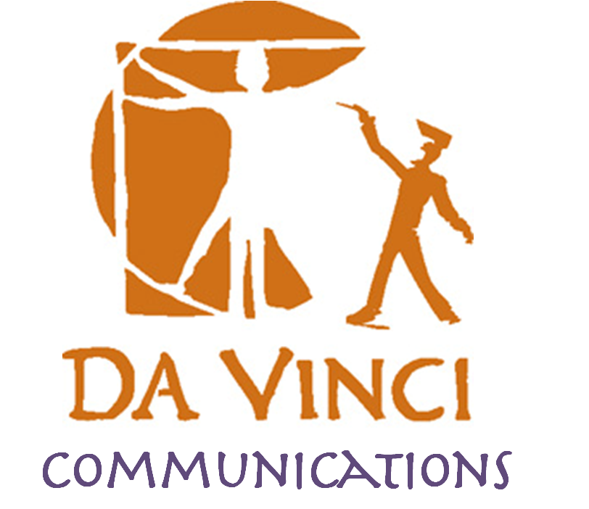
DVC Family Association Meeting Agenda

Meeting Date: Tuesday, January 21, 2014 @ 6pm

Mission Statement: The Da Vinci Schools Family Association is a non-profit organization dedicated exclusively to charitable and educational purposes in support of the students, teachers, and staff.

Objective: The objective of this association is to support the Da Vinci Schools; to encourage positive communication between parents, staff, and teachers of Da Vinci; to raise parents’ awareness and promote parents’ involvement in school issues; and to raise and administer funds and accept educational equipment and in order to provide additional educational benefits beyond those provided by the school district and state of California.

Topic: | Person: | Time: | Notes:
Welcome – sign in sheet reminder | Kim Cochran | 6:00 | Sign in sheet reminder  Annual Giving Campaign  Calendar  School Updates, Talent Show
Academic Updates | Nathan Barrymore | 6:15 | - Plan-It Project  - Be Heard!
College Info | Nathan Barrymore | 6:20 | - Grades  - Activities
Parent Projects | Project Leads | 6:40 | Updates on:  - Website communication  Lead: Kim Cochran  - Fundraising Lead: Kim Young
Demo | Nathan Barrymore | 7:00 | • Hippocampus – a way to learn physics

Contact Info:  Nathan Barrymore, Principal: nbarrymore@davincischools.org  Kim Merritt, English: kmerritt@davincischools.org  David Wilson, Math: dwilson@davincischools.org | Meredith Casalino, Physics: mcasalino@davincischools.org  Jason Maligmat, Resource: jmaligmat@davincischools.org  Jackie Martinez, Office Manager: jmartinez@davincischools.org
Family Association Meetings Upcoming Dates – Tuesdays at 6pm
Tuesday, February 18, 2014  Topic: College Night | (No April Meeting)
Tuesday, March 18, 2014  Topic: School and Internet Safety | Tuesday, May 13, 2014  JOINT MEETING – Design and Science at Science Forum  Topic: Seniors and Graduates share their experiences applying for and being at College

Sports update: (for more Sports info, contact Thomas Curry at tcurry@davincischools.org )
- Basketball and volleyball practice is ongoing
- Sports lineup includes -Flag Football, Soccer, Basketball, Volleyball & Running (Track/Cross Country)

